EXPERIMENT - 3
Set 3: Employee Performance Evaluation

Dataset: Employee Performance
Employee ID | Department | Years of Service | Performance Score
1 | Sales | 5 | 85
2 | HR | 3 | 92
3 | Marketing | 7 | 78
4 | Sales | 4 | 90
5 | HR | 2 | 76

Question 1
Create a line chart to visualize the performance trend of employees over time. Include a legend and labels.

R Code
# Set 3 - Q1: Line chart of performance scores by employee, grouped by department
emp_id <- 1:5
department <- c("Sales", "HR", "Marketing", "Sales", "HR")
years_of_service <- c(5, 3, 7, 4, 2)
performance_score <- c(85, 92, 78, 90, 76)

plot(emp_id, performance_score, type = "o", col = "darkgreen", lwd = 2, pch = 16,
main = "Employee Performance Trend",
xlab = "Employee ID", ylab = "Performance Score",
xaxt = "n", ylim = c(70, 100))
axis(1, at = emp_id, labels = emp_id)

legend("bottomright", legend = "Performance Score",
col = "darkgreen", lty = 1, pch = 16, lwd = 2)

Output
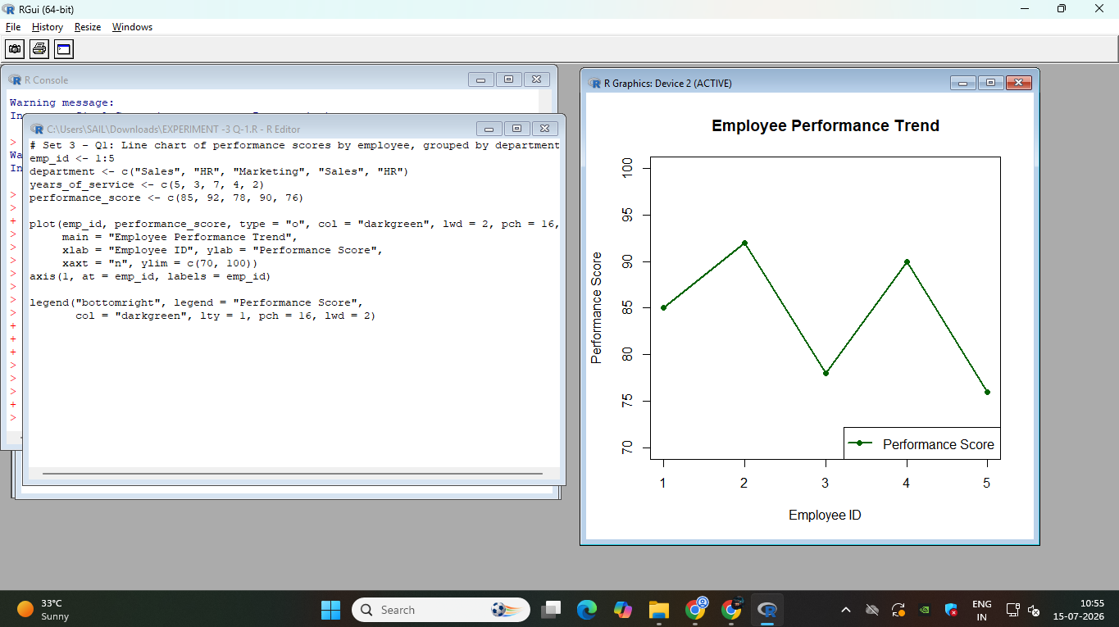

Question 2
Generate a bar chart showing the distribution of employees across different departments. Label the chart elements.

R Code
# Set 3 - Q2: Bar chart of employee count by department
department <- c("Sales", "HR", "Marketing", "Sales", "HR")

dept_table <- table(department)

barplot(dept_table,
main = "Distribution of Employees Across Departments",
xlab = "Department", ylab = "Number of Employees",
col = "coral", ylim = c(0, max(dept_table) + 1))

Output
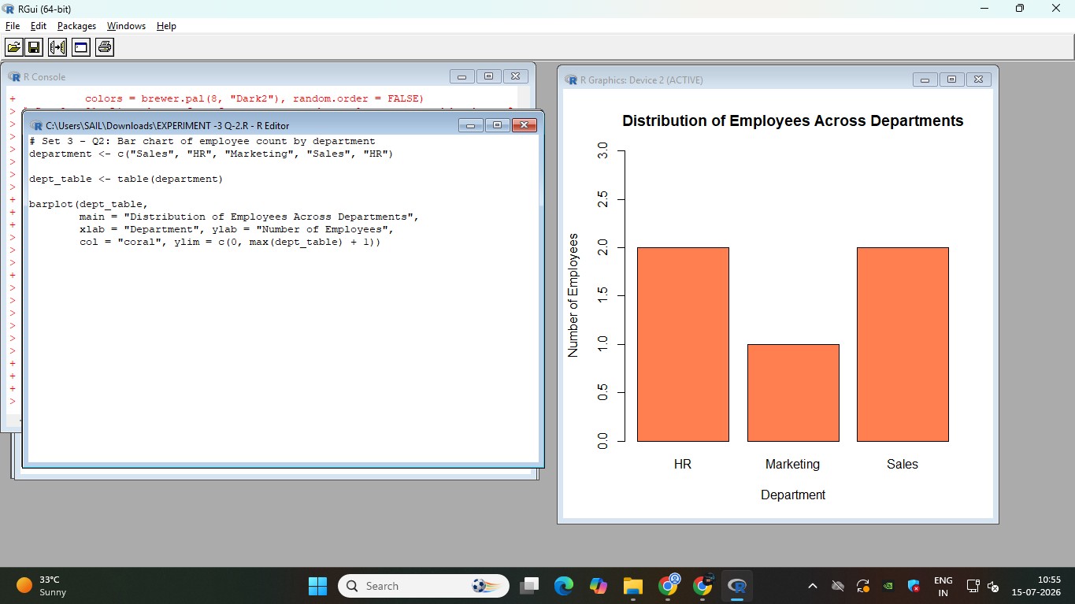

Question 3
Build a scatter plot to analyze the correlation between years of service and performance scores. Explain any insights.

R Code
# Set 3 - Q3: Scatter plot - years of service vs performance score
years_of_service <- c(5, 3, 7, 4, 2)
performance_score <- c(85, 92, 78, 90, 76)

plot(years_of_service, performance_score,
main = "Years of Service vs Performance Score",
xlab = "Years of Service", ylab = "Performance Score",
pch = 19, col = "purple")
abline(lm(performance_score ~ years_of_service), col = "blue", lwd = 2)

correlation <- cor(years_of_service, performance_score)
cat("Correlation between Years of Service and Performance Score:", round(correlation, 3), "\n")

if (correlation < -0.5) {
cat("Finding: There is a strong negative correlation between years of service and performance score.\n")
cat("This suggests that employees with more years of service tend to have lower performance scores\n")
cat("in this sample, indicating performance may depend more on individual factors than tenure alone.\n")
} else if (correlation > 0.5) {
cat("Finding: There is a strong positive correlation between years of service and performance score.\n")
cat("This suggests that longer-serving employees tend to perform better, possibly due to experience.\n")
} else {
cat("Finding: There is a weak or negligible correlation between years of service and performance score.\n")
cat("This suggests tenure alone does not strongly predict performance in this sample.\n")
}

Output
